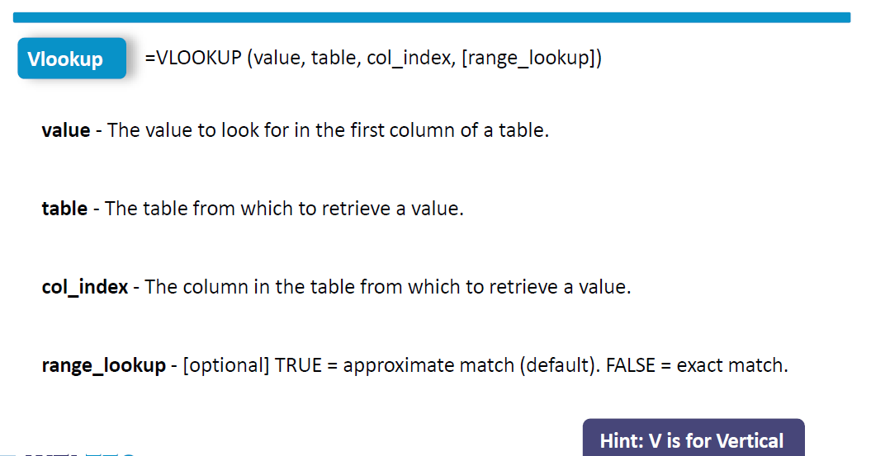

**How to Perform VLOOKUP with Wildcard in Excel (3 Methods)**



